**My (not bad) stock photo source**

**Pexels metadata for the win**

Where to find information related to stock photos? In [two](http://www.masalmon.eu/2018/01/04/bubblegumpuppies/) [previous](http://www.masalmon.eu/2018/01/07/rainbowing/) blog posts ,used Pexels, a website providing CC0 pictures which is quite nice. My goal was to obtain the titles and the tags of stock photos of “data science”: for instance if you look at [this picture](https://www.pexels.com/photo/black-laptop-beside-black-computer-mouse-inside-room-669996/), its tags are “business”, “contemporary”, “computer”, etc. Pexels tags are very useful metadata, saving me the effort to use machine learning methods to analyse images.

**Responsible webscraping**

When researching this post I discovered that Pexels has an API, documented [here](https://www.pexels.com/api/documentation/) but this API does not get you the title nor the tags associated to a picture so only webscraping could get me what I needed.

Webscraping is a powerful tool allowing one to [rectangle](https://speakerdeck.com/jennybc/data-rectangling) webpages but with great power comes great responsability. Being *able* to scrape a webpage does not mean you are *allowed* to. You could get sued or your IP could get blocked. I am far from being an expert but I often read [Bob Rudis’ blog](https://rud.is/b/) where I learnt about rOpenSci’s [robotstxt package](https://github.com/ropenscilabs/robotstxt) that does “robots.txt file parsing and checking for R” which in plain language means it checks for you what a webpage legally allows you to do. See below,

# how I'll find pictures

robotstxt::paths_allowed("https://www.pexels.com/search")

## [1] TRUE

# where tags live

robotstxt::paths_allowed("https://www.pexels.com/photo")

## [1] TRUE

robots.txt files often also tell you how often you can hit a page by defining a “crawling delay”. Sadly Pexels robots.txt doesn’t:

robotstxt::get_robotstxt("https://www.pexels.com")

## Sitemap: https://s3.amazonaws.com/pexels/sitemaps/sitemap.xml.gz

But Bob Rudis, who was patient and nice enough to answer my questions, told me that I should probably respect the rate limit defined in [Pexels API docs](https://www.pexels.com/api/documentation/). “Do not abuse the API. The API is rate-limited to 200 requests per hour and 20,000 requests per month.” As I recently explained in [a post on Locke Data’s blog](https://itsalocke.com/blog/some-web-api-package-development-lessons-from-hibpwned/), these days to limit rate of a function I use [the very handy ratelimitr package](https://github.com/tarakc02/ratelimitr) by [Tarak Shah](https://tarakc02.github.io/).

limited_get <- ratelimitr::limit_rate(httr::GET,

ratelimitr::rate(200, 60*60),# not more than 200 times an hour

ratelimitr::rate(1, 5))#not more than 1 time every 5 seconds

**Elegant webscraping**

At the time of the two aforelinked blog posts I had used [RSelenium](https://github.com/ropensci/RSelenium) to scroll down and get the download link of many pictures, but Bob Rudis wrote [an elegant and cool alternative](https://gist.github.com/hrbrmstr/4cabe4af87bd2c5fe664b0b44a574366) using query parameters, on which I’ll build in this post.

I first re-wrote the function to get all 15 pictures of each page of results.

get_page <- function(num = 1, seed = 1) {

message(num)

limited_get(

url = "https://www.pexels.com/search/data science/",

query = list(

page=num,

seed=seed

)

) -> res

httr::stop_for_status(res)

pg <- httr::content(res)

tibble::tibble(

url = rvest::html_attr(rvest::html_nodes(pg, xpath = "//a[@class='js-photo-link']"), "href"),

title = rvest::html_attr(rvest::html_nodes(pg, xpath = "//a[@class='js-photo-link']"), "title"),

tags = purrr::map(url, get_tags)

)

}

I re-wrote it because I needed the “href” and because it seems that the structure of each page changed a bit since the day on which the gist was written. To find out I had to write “a[@class=’js-photo-link’]” I inspected the source of a page.

Then I wrote a function getting tags for each picture.

get_tags <- function(url){

message(url)

url <- paste0("https://www.pexels.com", url)

res <- limited_get(url)

httr::stop_for_status(res)

pg <- httr::content(res)

nodes <- rvest::html_nodes(pg, xpath = '//a[@data-track-label="tag" ]')

rvest::html_text(nodes)

}

And finally I got results for 20 pages. I chose 20 without thinking too much. It seemed enough for my needs, and each of these pages had pictures.

ds_stock <- purrr::map_df(1:20, get_page)

ds_stock <- unique(ds_stock)

ds_stock <- tidyr::unnest(ds_stock, tags)

I got 300 unique pictures.

**What’s in a data science stock photo?**

Now that I have all this information at hand, I can describe data science stock photos!

**Data science tags**

library("ggplot2")

library("ggalt")

library("hrbrthemes")

tag_counts <- dplyr::count(ds_stock, tags, sort = TRUE)[1:10,]

dplyr::mutate(tag_counts,

tags = reorder(tags, n)) %>%

ggplot() +

geom_lollipop(aes(tags, n),

size = 2, col = "salmon") +

hrbrthemes::theme_ipsum(base_size = 16,

axis_title_size = 16) +

xlab("Tag") +

ggtitle("300 data science stock photos",

subtitle = "Most frequent tags. Source: https://www.pexels.com") +

coord_flip()

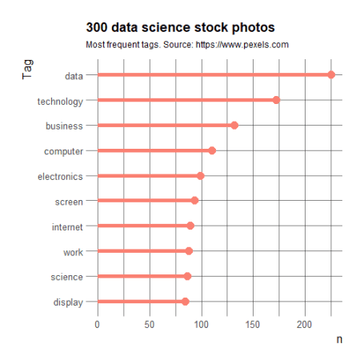

So the most common tags are data, technology, business and computer. Not too surprising!

**Data science scenes**

Now, let’s have a look at *titles* that are in general more descriptive of what’s happening/present on the photo (i.e. is the computer near a cup of coffee or is someone working on it). I tried using a technique described in [Julia Silge](https://juliasilge.com/)’s and [David Robinson](http://varianceexplained.org/)’s [Tidy text mining book](https://www.tidytextmining.com/): “Counting and correlating pairs of words with the widyr package” described in [this section of the book](https://www.tidytextmining.com/ngrams.html#counting-and-correlating-pairs-of-words-with-the-widyr-package) but it wasn’t too interesting because most correlation values were too low. One issue was probably my having too few titles: only half of pictures have titles! So I’ll resort to plotting most common bigrams, which I learnt in the [Tidy text mining book](https://www.tidytextmining.com/) as well.

stopwords <- rcorpora::corpora("words/stopwords/en")$stopWords

ds_stock %>%

dplyr::filter(!is.na(title)) %>%

dplyr::select(title) %>%

unique() %>%

tidytext::unnest_tokens(bigram, title,

token = "ngrams", n = 2) %>%

tidyr::separate(bigram, c("word1", "word2"), sep = " ",

remove = FALSE) %>%

dplyr::filter(!word1 %in% stopwords) %>%

dplyr::filter(!word2 %in% stopwords)%>%

dplyr::count(bigram, sort = TRUE) %>%

dplyr::mutate(bigram = reorder(bigram, n)) %>%

head(n = 10)%>%

ggplot() +

geom_lollipop(aes(bigram, n),

size = 2, col = "salmon") +

hrbrthemes::theme_ipsum(base_size = 16,

axis_title_size = 16) +

ggtitle("300 data science stock photos",

subtitle = "Most frequent bigrams in titles. Source: https://www.pexels.com")+

coord_flip()

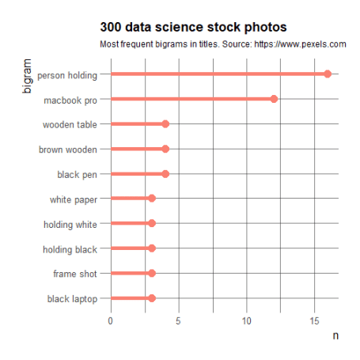

So there’s a lot of holding computer happening, and these laptops are either black or white… And well Macbook Pro probably looks more professional?

**Hold my laptop and watch…**

my trying to find a good post conclusion! In this post, I tried to responsibly and elegantly scrape rich photo metadata from Pexels to characterize stock photos of data science. Using tags, and most common bigrams in titles, I found that data science stock photos are associated with data, business and computers; and that they often show people holding computers. Now, you’ll excuse me while I try and comfort my poor pink laptop that feels a bit too un-data-sciency.